Session 13

Assignment 2 Questions

*Session 13: Assignment 2*

**Table of Contents**

1. Introduction

2. Problem Statement

3. Output

**1. Introduction**

This assignment will help you to consolidate the concepts learnt in the session.

**2. Problem Statement**

● A Fibonacci series (starting from 1) written in order without any spaces in between, thus

producing a sequence of digits.

Write a Scala application to find the Nth digit in the sequence.

○ Write the function using standard for loop

○ Write the function using recursion

**3. Output**

**import** scala.io.StdIn

**object** fibo1 {

**def** fiboFor(n: Int,nth: Int): Int ={

**var** sum = "1"

**if** (n < 2)

{

println(n)

n

}

**else**

{

**var** result : Int = 0

**var** first : Int = 0

**var** second : Int = 1

**for**(i<-1 until n)

{

result = first + second

first = second

second = result

sum = sum + result

}

printmethod(n,sum,nth)

result

}

}

**def** printmethod(n: Int,sequence: *String* ,nth: Int) : Unit = {

println("the febonacci series : "+sequence)

println("the digit at place nth of FIBO sequence :" + sequence.charAt(nth -1).toChar )

}

**def** main(args: Array[*String*]):Unit = {

println("\nFiBONACCI SERIES")

println("\n FIBONACCI SERIES")

println("--------------------")

println("Enter the Number:")

**var** number: Int = scala.io.StdIn.readLine().toInt

println("Enter the Nth digit to find fibonacci number:")

**var** nth_number: Int = scala.io.StdIn.readLine().toInt

println("---------------------")

fiboFor(number,nth_number)

}

}

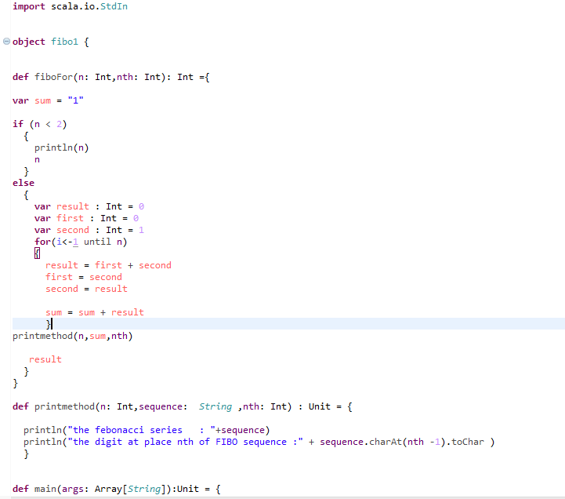

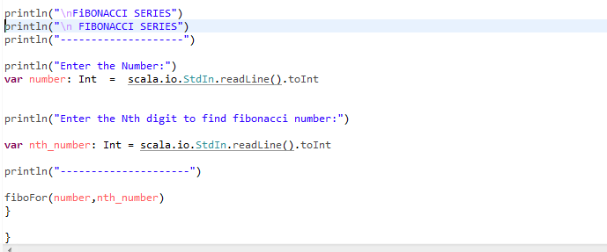

Output:

